Copyright for test papers and marking guides remains with *West Australian Test Papers.*

Test papers may only be reproduced within the purchasing school according to the advertised Conditions of Sale.

Test papers should be withdrawn after use and stored securely in the school until Thursday 2nd July 2020.



**SEMESTER ONE**

**MATHEMATICS**

**SPECIALIST**

**UNIT 1**

**2020**

**SOLUTIONS**

**Calculator−free Solutions**

1. (a) (i) −**b** ✓

(ii) 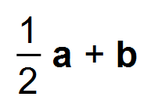 ✓

(b) 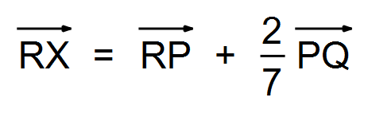 ✓

= 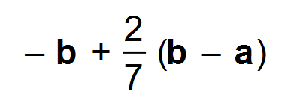 ✓

= 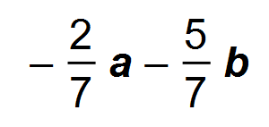 ✓ [5]

2. (a) (i) 5 ✓

(ii) 21 ✓

(b) (i) *x =* 3 ✓

(ii) *x =* 4 ✓

(iii) *x =* 7 ✓

(iv) *x =* 2 ✓

(c) (i) 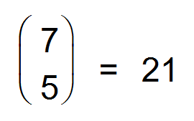 ✓

(ii) 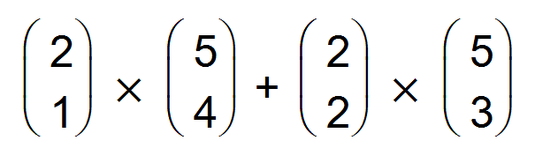 ✓

= 20 ✓

(d) (i) 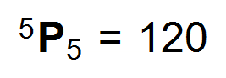 ✓

(ii) 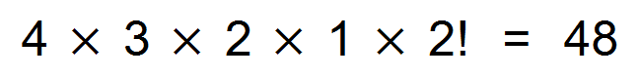 ✓✓ [12]

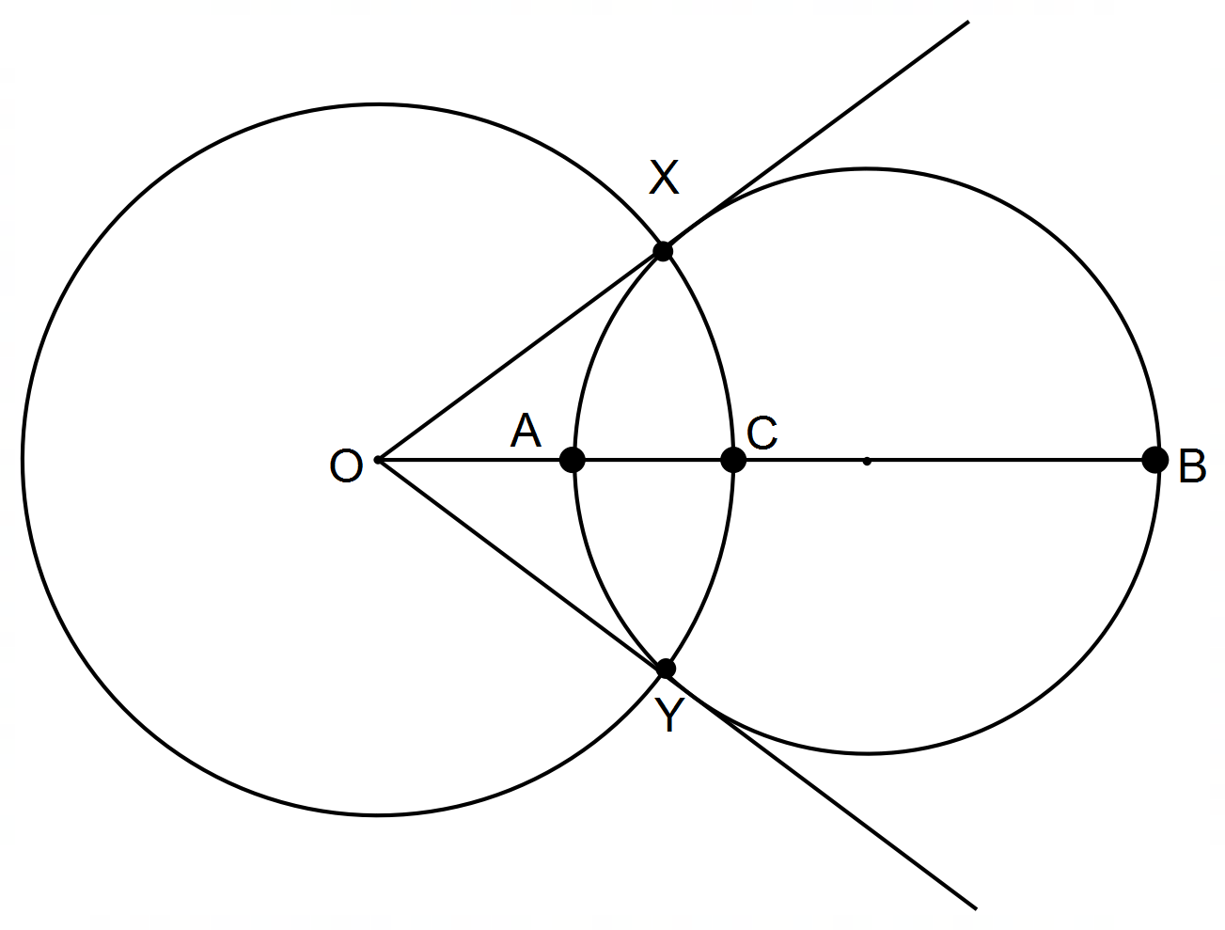3. (a) (i)

✓

(ii) OA x OB = OC2

But OC = OX

∴ OA x OB = OX2 ✓

This is the converse of the secant/tangent theorem

∴ OX is a tangent ✓

OA x OB = OC2

But OC = OY

∴ OA x OB = OY2 ✓

This is the converse of the secant/tangent theorem

∴ OY is a tangent ✓

(b) 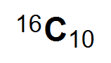 or 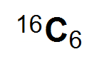 ✓✓

(c) (i) 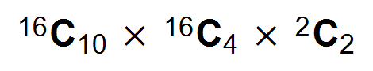 ✓✓

(ii) 3! = 6 ways ✓ [10]

4. (a) (i) −**i** − 13**j** ✓

(ii) 5 ✓

(iii) 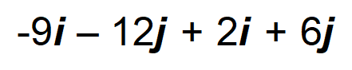 ✓

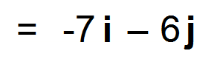 ✓

(iv) 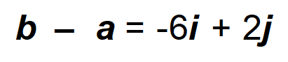 ✓



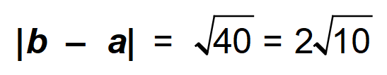 ✓

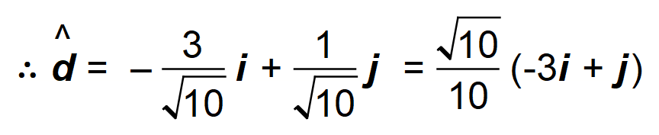 ✓

(b) 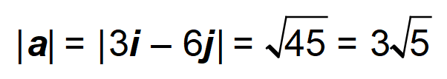

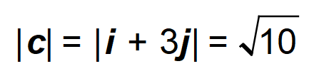

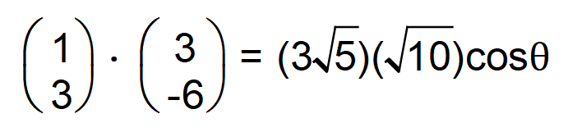 ✓

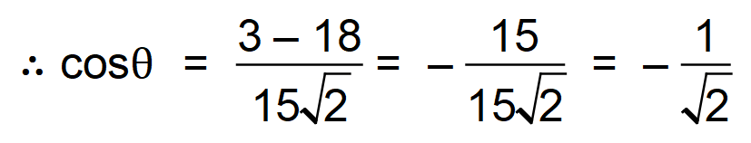 ✓

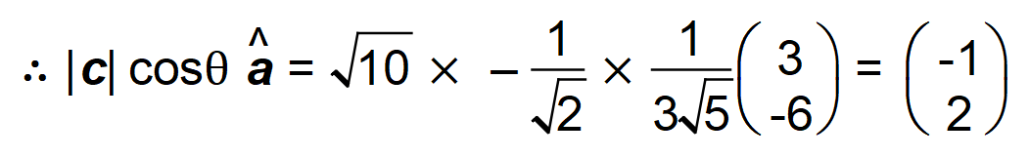 ✓✓

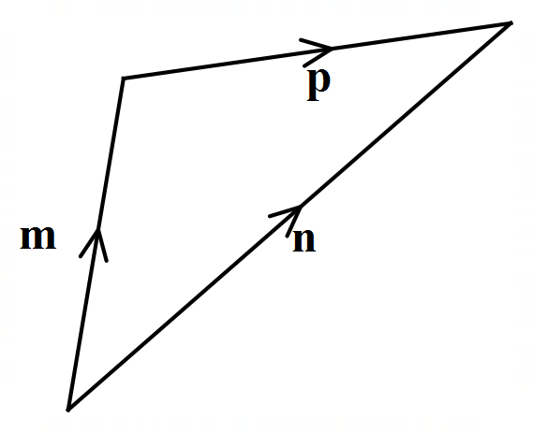 (c)

✓ [12]

5. (a) 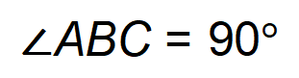 ✓

Thale’s Theorem ✓

(b) 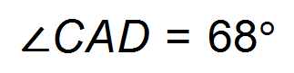 ✓

Revolution equal to 360 degrees ✓

(c) 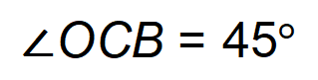 ✓

Equal angles at base of isosceles triangle ✓ [6]

6. 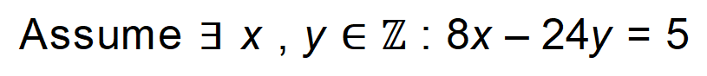 ✓

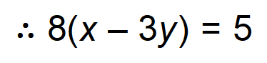

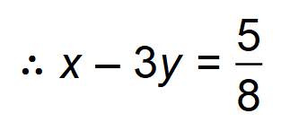 ✓

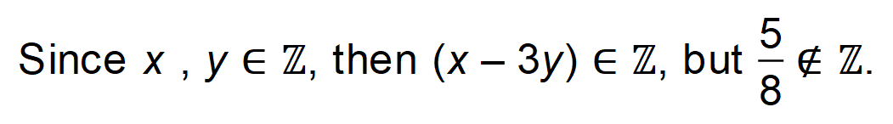 ✓

This is a contradiction as (*x – 3y*) cannot both belong and not belong

to the integer set. ✓

:. False, there are no integers for which this statement is true. ✓ [5]

**Calculator−Assumed Solutions**

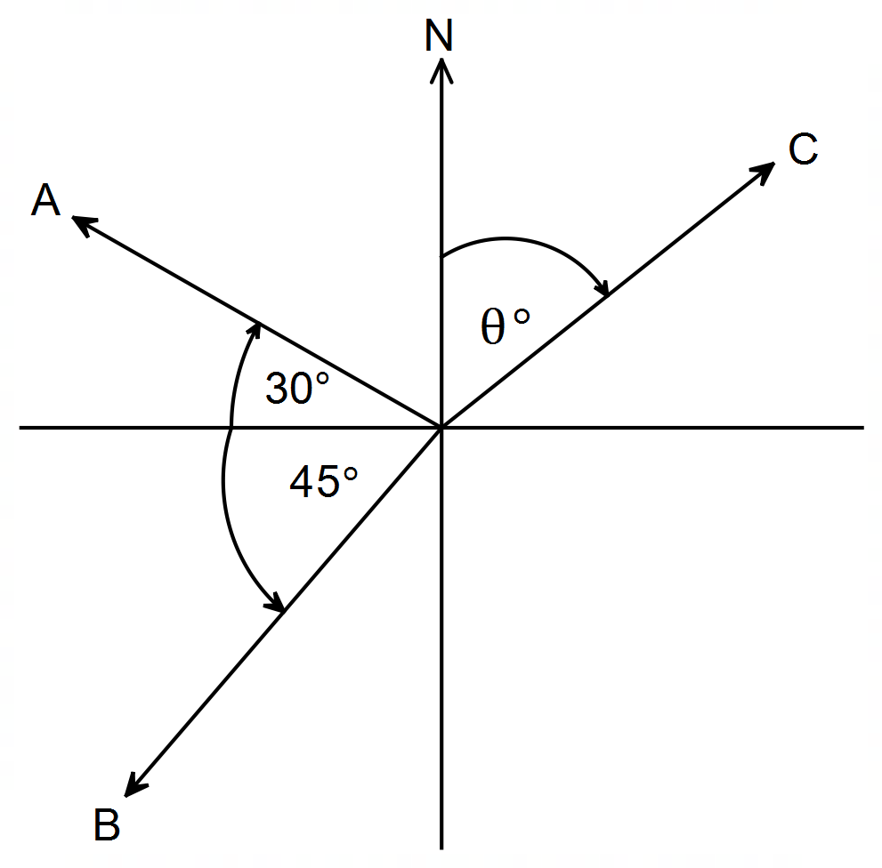7.

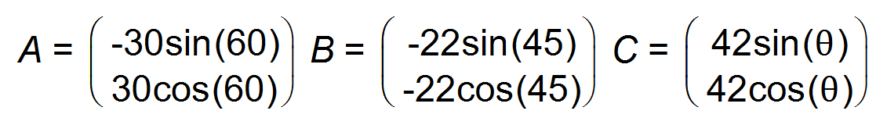 ✓✓

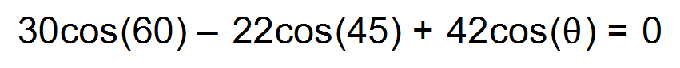 ✓

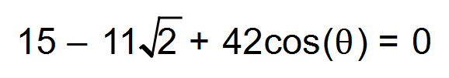

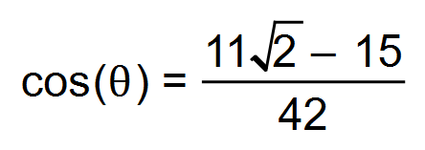

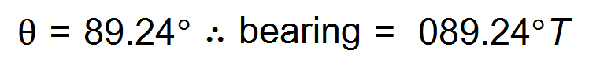 ✓

 ✓

*v =* 0.46 km/h ✓ [6]

8. (a) (i) **LM** parallel to *x*–axis so *b* = 5 ✓

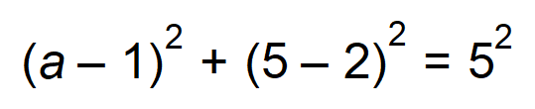 ✓

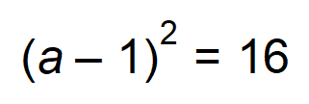

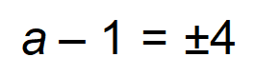

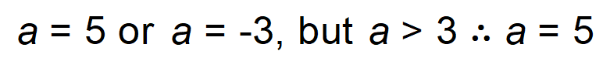 ✓

M = (5, 5)

(ii) 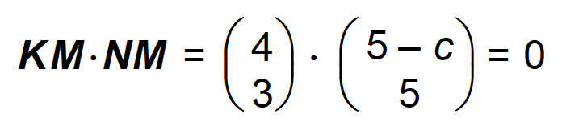 ✓

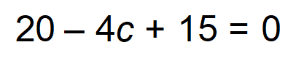

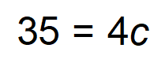

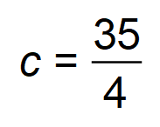 ✓

(b) (i) *x* = 5 ✓

*y* = 2 ✓

(ii) If *y* = 2 & *x* ≥ 6, then ***BC* *// AD*** ✓

If ***AB* *// DC*** ✓

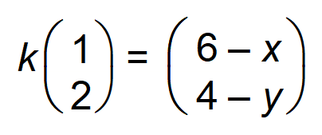 ✓

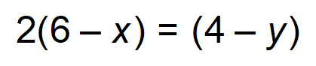

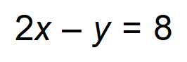 ✓

(iii) 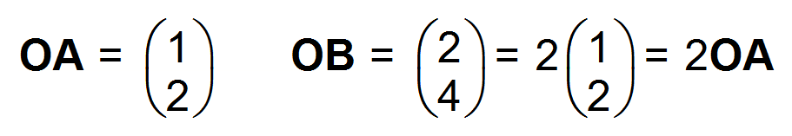 ✓

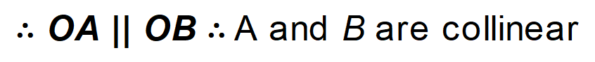 ✓ [13]

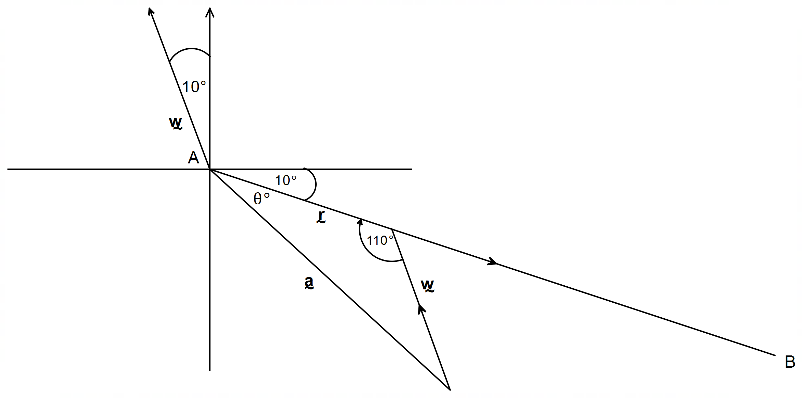9. (a)

✓✓

(b) 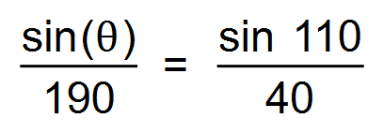

∴ 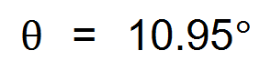 ✓

∴ Bearing = 110°T ✓

(c) 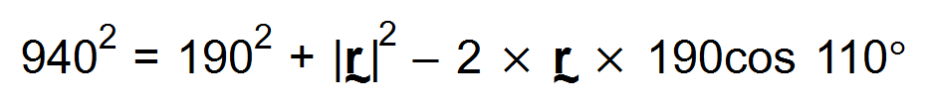 ✓

∴ 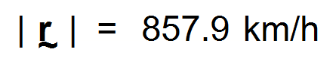 ✓

∴ Time taken = 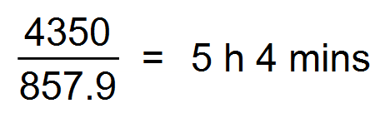 ✓ [7]

10. (a)

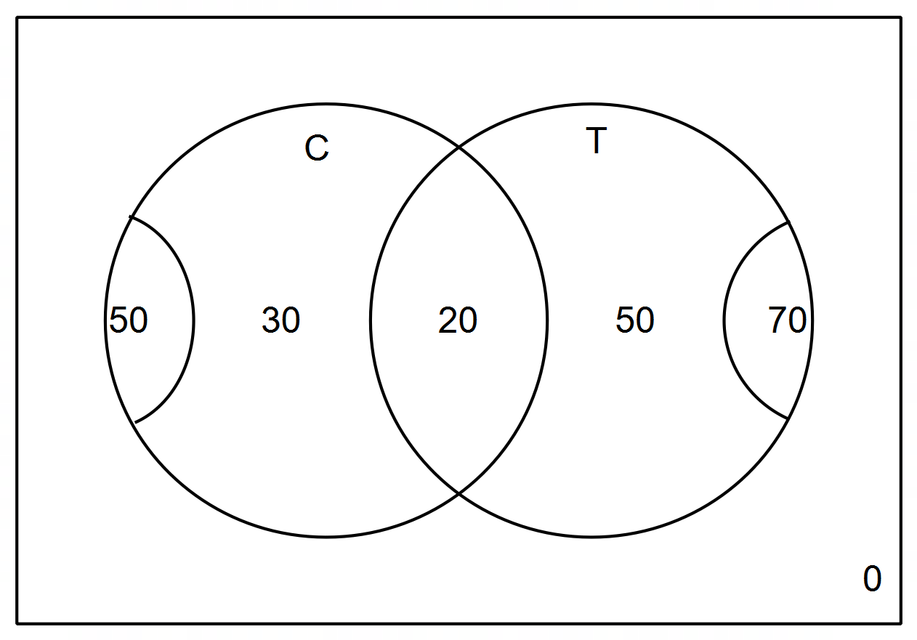

∴ 50 like tea only ✓

(b) None like neither ✓

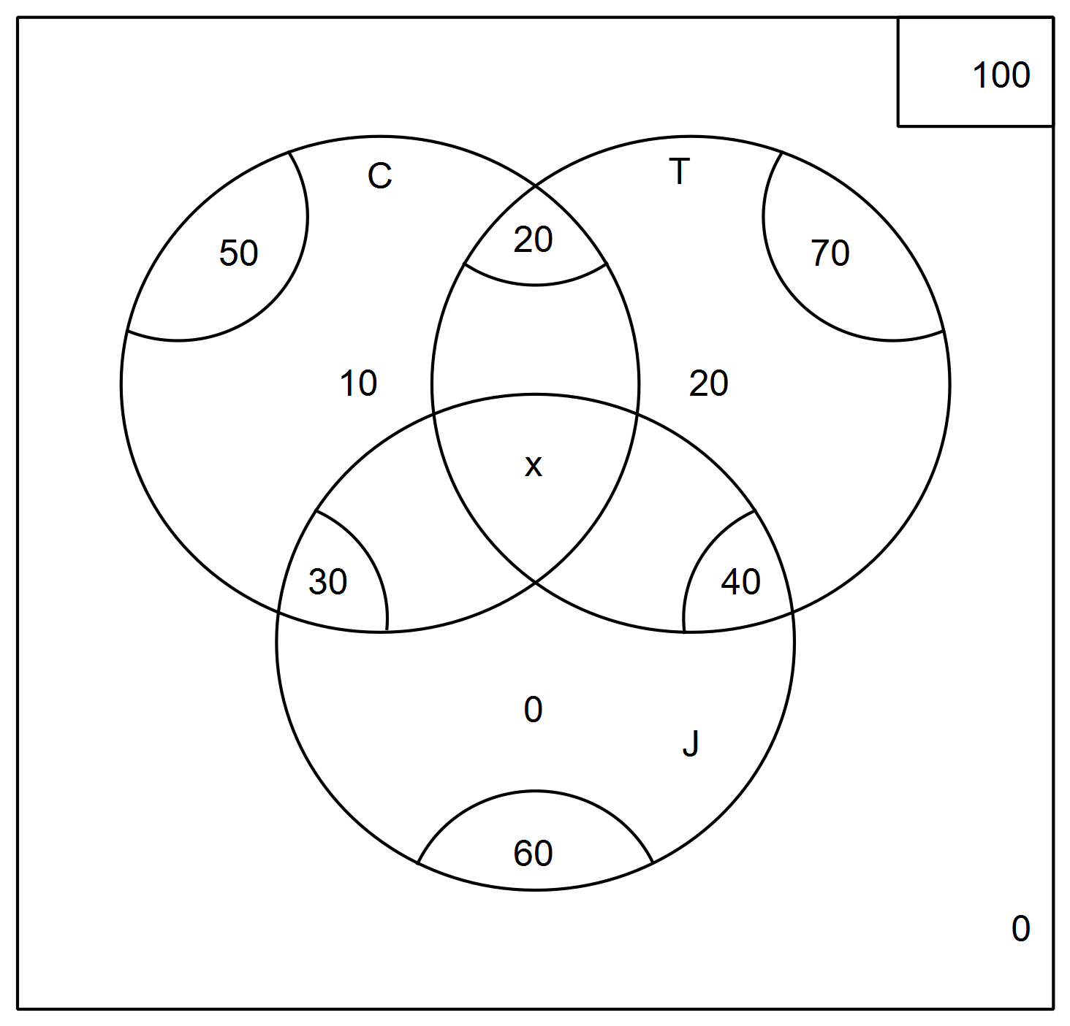 (c)



∴ 100 = 70 + 50 + 60 − 20 − 40 − 30 + *x* ✓

∴ = 90 + *x* ✓

∴ *x* = 10 ✓

(d) (i) 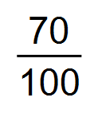 ✓

(ii) 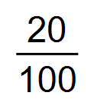 ✓

(e) 41 ✓ [8]

11. (a) 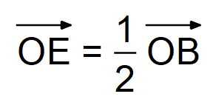 ✓

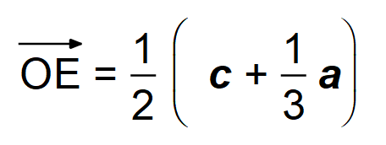

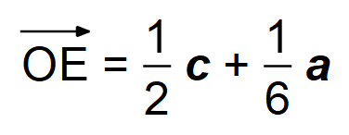 ✓

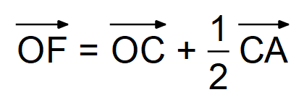 ✓

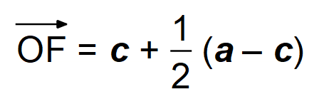

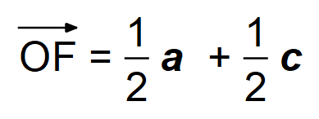 ✓

(b) 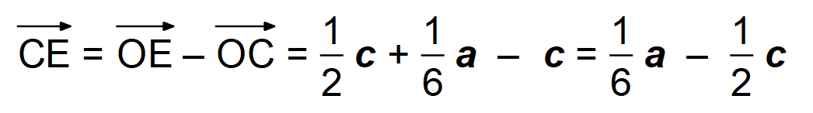 ✓

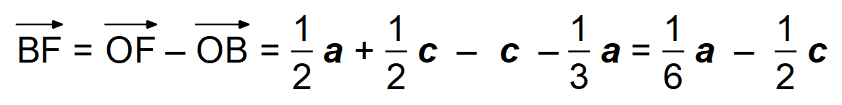 ✓

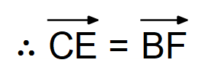

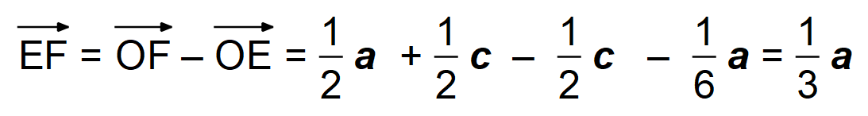 ✓

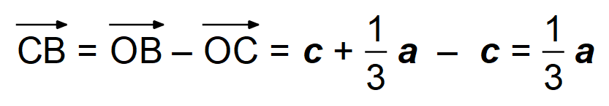 ✓ [8]

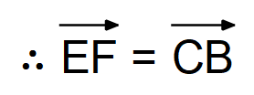

12. (a) 3 > 2 but −3 < −2 is false ✓

(b) “If the triangle is not isosceles, then the triangle does not

have two equal sides.” ✓

Yes is it always true since the original implication is always

true by definition of isosceles triangles. ✓

(c) “If n is divisible by 4, then n is divisible by 8”. ✓

The converse is not always true, as shown by the

counter-example where n = 12 ✓

(d) FOR ALL natural numbers p, EXISTS a real number q,

such that q is one less than p. ✓✓ [7]

13. (a)

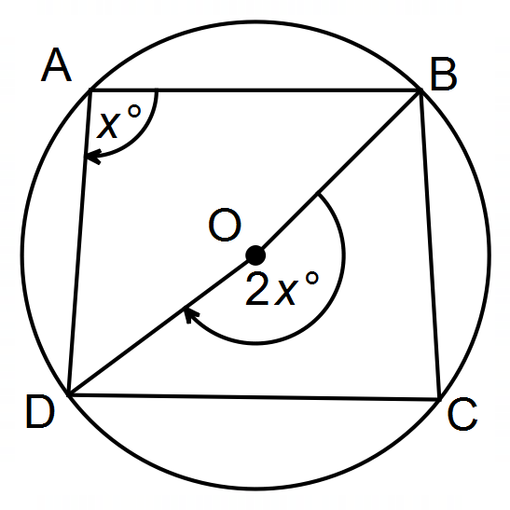

Let ∠BAD = *x*°

∴ reflex ∠BOD = 2*x*° Angle at the centre theorem ✓

Similarly let ∠BCD = *y*°

∴ ∠BOD = 2*y*° Angle at the centre teorem ✓

Since 2*x* + 2*y* = 360

then *x* + *y* = 180° ✓

Hence ∠BAD + ∠BCD = 180° ✓

QED

(b) ∠EAG + ∠BCD = 180° Cyclic quadrilateral

∴ ∠EAG ≡ ∠ECF ✓

In ΔEAG and ΔECF

∠AEG ≡ ∠CEF Bisector ✓

∠EAG ≡ ∠ECF Proven ✓

∴ ∠CFE ≡ ∠BFG Vertically Opposite

∴ ∠AGF ≡ ∠BFG QED ✓

(c) (i) Converse ✓

(ii) Yes ✓ [10]

14. (a) (i) 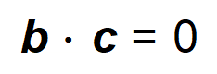

∴ 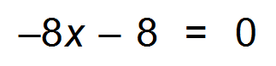 ✓

* *x* = −1 ✓

(ii) 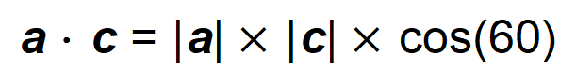 ✓

∴ 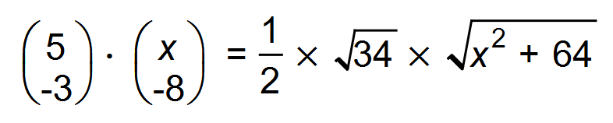 ✓

∴ 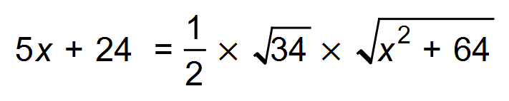

∴ 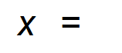 −0.13 ✓

(iii) **a** − **b** = 13**i** − 4**j** ✓

∴ | **a** − **b** | = 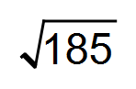

∴ 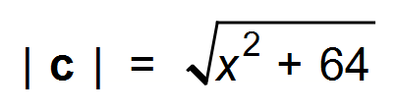

∴ 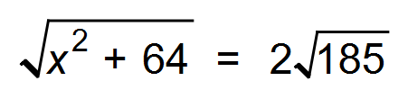 ✓

∴  ✓

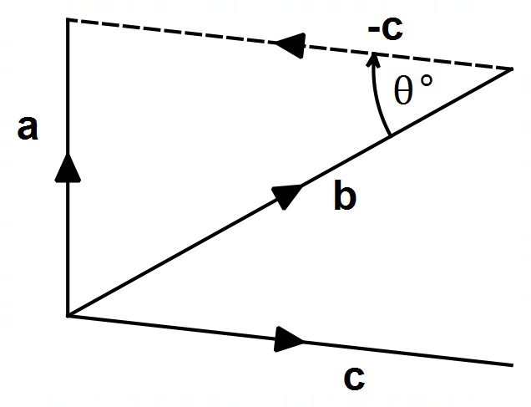(b) (i)

✓✓

(ii) cos(0) = 1 ✓

So, the dot product of a vector with itself is its magnitude

squared multiplied by 1.

(iii) 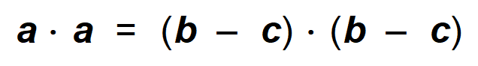

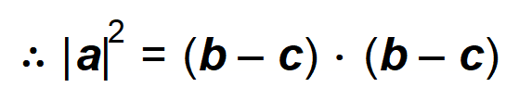

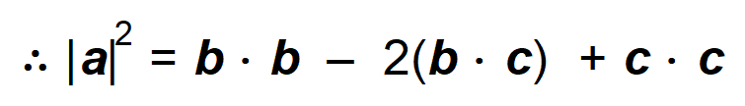 ✓

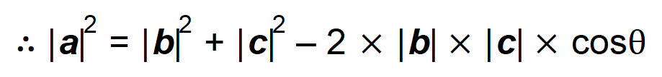 ✓

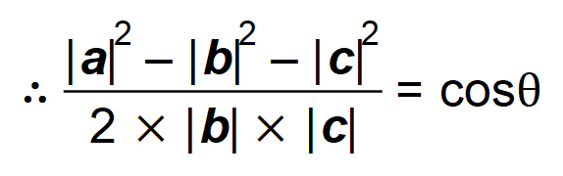 ✓ [14]

15. (a) 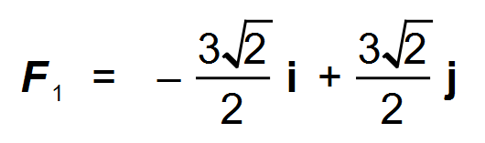 ✓

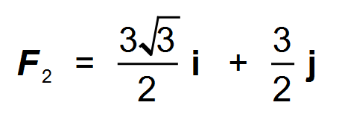 ✓

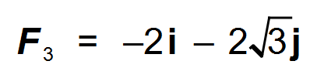 ✓

∴ ***F***1 + ***F***2 + ***F***3 = 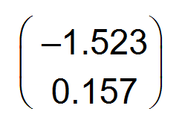 ✓

∴ 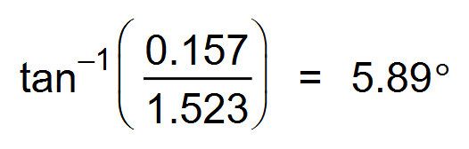 ✓

∴ 276°T ✓

(b) **a** + **b** = −5**i** + **j** ✓

**c** = 5**i** − **j** ✓

**| c | =** 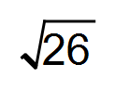 ✓

Direction = 101°T ✓ [10]

16.  ✓

 ✓

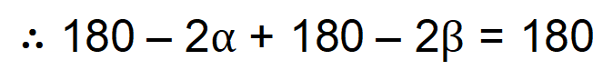 ✓

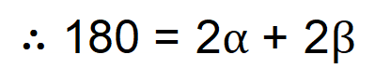

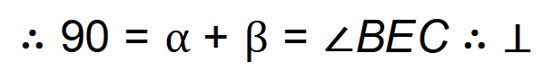 ✓ [4]

17. 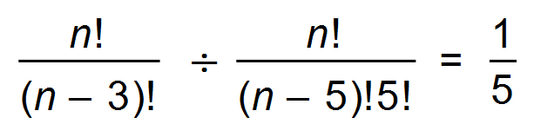 ✓

∴ 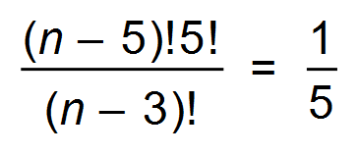

∴ 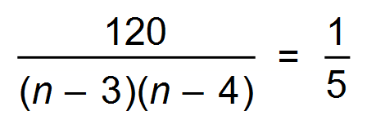 ✓

∴ 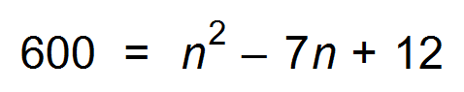 ✓

∴ 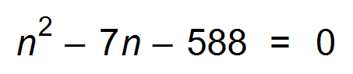 ✓

∴ 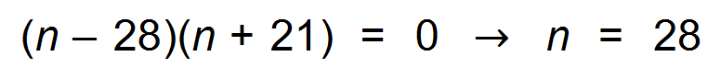 ✓ [5]

18. (a) Independent term is the middle term. ✓

∴ 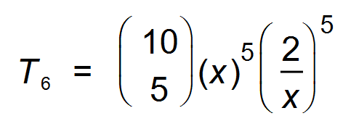 ✓

∴ 8064 ✓

(b)



✓



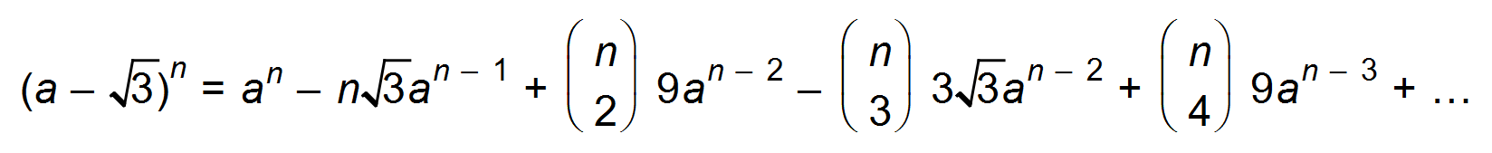✓

Hence,

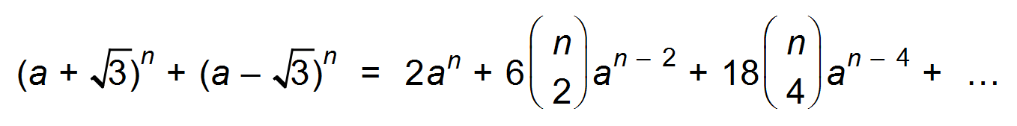 ✓✓

∴ 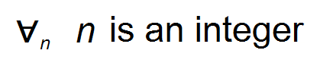 ✓ [8]